Business Requirements Document (BRD)
Project: Hezop PID Reader

Table of Contents
- Document Version History
- Executive Summary
- Project Overview & Strategic Context
  - Industry Landscape and Digital Transformation Imperative
  - Problem Statement Deep Dive
  - Project Objectives & Success Criteria
  - Project Scope (In-Scope / Out-of-Scope)
- Stakeholder Analysis & User Personas
- Solution Vision & Value Proposition
- Detailed Requirements Specification
  - Business & Process Requirements
  - Functional Requirements
  - Non-Functional Requirements
  - Data Requirements
- System Context & Technical Architecture
  - System Context Diagram
  - High-Level System Architecture
  - AI/ML Engine Components
- Process Flows & Use Case Scenarios
  - End-to-End Value Chain Process Flow
  - Core User Workflows
  - Detailed Use Case Specifications
- Data Model & Output Specifications
- User Interface & Experience Principles
- Assumptions, Constraints & Dependencies
- Risk Assessment & Mitigation
- Appendices
  - Glossary of Terms
  - Acronyms
  - References to Industry Standards

1. Document Version History
Version | Date | Author | Change Description
0.1 | 2023-10-19 | Hezop BA Team | Initial Draft
0.5 | 2023-10-23 | Hezop BA Team | Added detailed requirements and diagrams
1.0 | 2023-10-25 | Hezop BA Team | Finalized core requirements
2.0 | 2023-10-26 | Hezop Steering Committee | Approved version with expanded strategic context and risk assessment

2. Executive Summary
The industrial world stands at the precipice of its fourth revolution, where data is the new currency of efficiency, safety, and competitive advantage. Yet, a fundamental barrier persists: critical engineering knowledge remains imprisoned in static drawings. The Hezop PID Reader project is a decisive step to shatter this barrier.
This document outlines the business requirements for an AI-powered engineering intelligence platform designed to autonomously interpret Piping and Instrumentation Diagrams (P&IDs). These drawings, the universal language of process engineering, detail every component, connection, and control logic within industrial plants—from oil refineries to pharmaceutical manufacturing. Currently, extracting this data is a manual, costly, and error-prone endeavor, creating a significant bottleneck for digital initiatives like Digital Twins, predictive maintenance, and comprehensive safety analysis.
Hezop PID Reader leverages state-of-the-art computer vision, natural language processing, and domain-specific knowledge graphs to transform these drawings into structured, queryable, and actionable data. The solution delivers not merely automation, but engineering comprehension. It identifies equipment, instruments, and pipelines, understands their relationships, and outputs a robust digital dataset ready to fuel the next generation of industrial software. The expected impact is transformative: reducing engineering data digitization efforts by over 80%, mitigating human-error-related risks, and unlocking the latent value within decades of accumulated plant knowledge to drive smarter, safer, and more efficient operations.
3. Project Overview & Strategic Context
3.1 Industry Landscape and Digital Transformation Imperative
The global process industries (Oil & Gas, Chemicals, Power, Pharmaceuticals) are under immense pressure to improve operational efficiency, ensure safety and compliance, and extend the life of aging assets. Digital transformation, centered on concepts like the Industrial Internet of Things (IIoT) and Digital Twins, promises unprecedented levels of visibility and control. However, these advanced analytics and simulation platforms require high-fidelity, structured data about the physical plant as their foundational input. This "as-designed" data primarily resides in P&IDs. The inability to automatically digest this information creates a "data desert" at the very heart of digitalization efforts, forcing companies to rely on manual population or settle for incomplete models. Hezop PID Reader directly addresses this critical data ingestion challenge, positioning itself as an essential enabler for the entire digital transformation stack.
3.2 Problem Statement Deep Dive
The reliance on manual P&ID interpretation creates a cascade of operational deficiencies:
- Chronic Inefficiency and Cost: Engineers and designers spend an inordinate amount of time visually tracing lines and cross-referencing tags between multiple drawing sheets. A single capital project can involve thousands of P&IDs. This manual process delays project timelines, increases engineering overhead, and defers time-to-value for plant upgrades.
- Propagation of Risk: Human error in reading or transcribing tag numbers, line specifications, or instrument set points can have severe consequences. These errors may propagate into maintenance work orders, procurement systems, and safety studies (like HAZOP), potentially leading to equipment failure, environmental incidents, or safety hazards.
- The "Tribal Knowledge" Crisis: As a generation of experienced engineers retires, the nuanced understanding of plant systems—often mentally cross-referenced across drawings—is lost. This knowledge gap makes troubleshooting harder, training new personnel more difficult, and increases operational risk.
- Data Silos and Integrity Issues: Even when data is manually entered into systems like a Computerized Maintenance Management System (CMMS), it quickly becomes stale. P&IDs are living documents that undergo revisions (MOCs - Management of Change). Manually synchronizing these changes across all digital records is virtually impossible, leading to conflicting sources of truth.
- Impediment to Innovation: Advanced applications—such as AI-driven optimization, automated compliance checking, or dynamic process simulation—require machine-readable data streams. Static drawings are incompatible with these technologies, stifling innovation and leaving potential efficiency gains untapped.
3.3 Project Objectives & Success Criteria
The project aims to deliver a commercially viable product that achieves the following strategic objectives:
Strategic Objective | Key Performance Indicator (KPI) | Target
Achieve Market-Leading Accuracy | Weighted F1 Score for entity recognition (Equipment, Instrument, Line) against a validated industry benchmark dataset | ≥ 0.95
Deliver Exceptional Operational Efficiency | Reduction in engineering hours required for P&ID data digitization per standard project | ≥ 80%
Ensure Rapid Time-to-Value | Time from initial drawing upload to availability of validated, structured data for a 500-sheet project | < 5 Business Days
Drive User Adoption and Satisfaction | Net Promoter Score (NPS) among pilot users (engineers and digitalization leads) | > +40
Establish Robust Integration Capability | Number of pre-built connectors/adapters for major enterprise systems (CMMS, EDB, Data Lakes) | 3 (Initial Release)

3.4 Project Scope
In-Scope for MVP (Phase 1):
- A cloud-hosted SaaS application with a secure web portal.
- Processing of 2D P&ID drawings in PDF (vector and raster), JPEG, PNG, and TIFF formats.
- Recognition of a core library of ISA S5.1 and common industry P&ID symbols.
- Extraction of equipment tags, instrument tags, line numbers, and basic annotations.
- Inference of direct physical connectivity between adjacent symbols via lines.
- Output of a single, consolidated structured data file (JSON) per processed project.
- A web-based validation interface for user review and correction.
- User and project management functionality.
Out-of-Scope:
- Interpretation of 3D models, isometric drawings, or loop diagrams.
- Extraction of non-standard, company-specific symbols without custom training.
- Automated understanding of complex control logic or interlocks.
- Direct, real-time integration with live operational technology (OT) sensor networks.
- On-premise deployment architecture in the initial phase.
- Generation of new or revised P&ID CAD files.

4. Stakeholder Analysis & User Personas
Stakeholder Group | Primary Influence / Interest | Key Goals & Motivations | Potential Concerns
VP of Operations / Plant Manager | Budget, Operations | Reduce downtime, improve maintenance, ensure safety | Cost justification, data accuracy
Digital Transformation Lead | Strategy, Integration | Enable digital twins, unified asset data | Integration complexity, scalability
Senior Process Engineer | Technical Accuracy | Save time, preserve design intent | Trust in AI, handling legacy drawings
Maintenance Planner | Work Order Planning | Accurate CMMS data, correct spare parts | Data mapping, update frequency
IT / Security Manager | Security, Compliance | Cloud security, auditability | Data residency, vulnerabilities
Hezop Development Team | Product Delivery | Clear requirements, scalability | Scope creep, unrealistic accuracy

Primary User Persona: "Validation Engineer"
- Name: Alex Chen
- Role: Instrumentation Engineer, 8 years experience
- Context: Tasked with validating the data extracted from a suite of legacy refinery P&IDs for a digital twin project.
- Goals: Quickly verify the AI's work, correct any misinterpretations efficiently, and export a "golden record" dataset with confidence.
- Frustrations: Current manual method is tedious and error-prone; worries the AI tool might create more work if it's inaccurate or difficult to correct.

5. Solution Vision & Value Proposition
Hezop PID Reader is more than a parsing tool; it is an Engineering Intelligence Platform. Our vision is to become the indispensable bridge between the analog legacy of industrial design and the digital future of autonomous operations. While competitors may offer generic OCR or drawing visualization, Hezop's core differentiator is its domain-trained cognition. The system is built with an understanding of process plant hierarchy, standard symbology semantics, and the implicit relationships that define a functioning industrial system.
The value proposition is articulated across three pillars:
- Accelerate Digital Foundation: We provide the critical, structured data layer that enables Digital Twins, Asset Performance Management, and advanced analytics, reducing the time and cost to launch these initiatives from months to weeks.
- De-risk Operations: By eliminating manual data entry errors and providing a single, auditable source of truth for plant design data, we directly contribute to safer maintenance procedures, more accurate safety studies, and reliable compliance documentation.
- Unlock Engineer Potential: We free highly skilled engineers from the drudgery of manual tracing and data logging, allowing them to focus on higher-value tasks such as optimization, troubleshooting, and innovation.
This solution is positioned not as a cost center, but as a strategic capability multiplier, enhancing the ROI of all downstream digital investments.
6. Detailed Requirements Specification
6.1 Business & Process Requirements
These requirements define the high-level business needs and the intended impact on organizational processes.
ID | Business Requirement Description | Priority | Associated KPI
BR-001 | Enable creation of a digital searchable inventory from P&IDs 80% faster than manual methods | High | Engineering Hour Reduction
BR-002 | Improve accuracy and consistency of asset data for CMMS and integrity systems | High | Data Error Rate Reduction
BR-003 | Support population and updates of Digital Twin platforms | High | Integration Success Rate
BR-004 | Enable faster and more comprehensive HAZOP/PHA studies | Medium | Study Preparation Time
BR-005 | Provide intuitive validation UI for engineers without data science skills | High | User Adoption (NPS)

6.2 Functional Requirements
These specify the discrete capabilities the system must offer to users.
File Ingestion & Management Module:
ID | Requirement | Acceptance Criteria
FR-101 | Create projects to organize related P&IDs | Project can be named, described, users assigned
FR-102 | Upload files via UI or API | Batch upload supported, progress shown
FR-103 | Validate file formats | Accepts PDF, JPG, PNG, TIFF
FR-104 | Generate thumbnail previews | Preview available within 30 seconds
AI Processing Core Module:
ID | Requirement | Acceptance Criteria
FR-201 | Detect individual sheets in multi-page PDFs | Each page processed independently
FR-202 | Detect equipment symbols | ≥ 98% recall on supported symbols
FR-203 | Extract and associate tags | ≥ 95% correct association
FR-204 | Classify instruments by type and function | Correct distinction (e.g., FV vs XV)
FR-205 | Trace piping lines and connections | Handles sheet boundaries correctly
Data Validation & Export Module:
ID | Requirement | Acceptance Criteria
FR-301 | Interactive viewer with highlighted data | Clicking symbol shows properties
FR-302 | Allow correction of extracted data | Changes saved and reused for training
FR-303 | Rule-based validation engine | Flags violations clearly
FR-304 | Export validated JSON | Passes schema validation
FR-305 | Pre-built export templates | At least one CMMS-ready CSV

6.3 Non-Functional Requirements
These define the quality attributes of the system.
- Performance:
  - The 95th percentile latency for processing a standard A1-size vector PDF shall be under 90 seconds.
  - The search interface shall return results from a project containing 10,000 equipment entities within 2 seconds.
- Scalability: The system architecture shall support concurrent processing of at least 50 drawing sheets across all tenants without degradation of the performance SLA.
- Availability: The application shall maintain 99.5% uptime, excluding scheduled maintenance windows communicated 72 hours in advance.
- Usability: A trained user shall be able to complete the validation of a moderately complex P&ID sheet (≈50 symbols) within 10 minutes using the provided tools.
- Security: All data in transit shall be encrypted using TLS 1.2+. Data at rest shall be encrypted using AES-256. The system shall support SSO (SAML 2.0) for enterprise authentication.
- Maintainability: The AI model's performance metrics (precision, recall) shall be continuously logged and monitored via a dedicated dashboard to detect concept drift.
7. System Context & Technical Architecture
7.1 System Context Diagram
The following defines the key external entities that interact with the Hezop PID Reader system and the data flows between them.
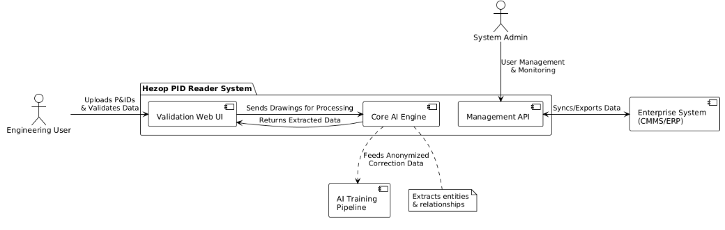
7.2 High-Level System Architecture
The system follows a modular, microservices-inspired architecture deployed on a cloud platform.
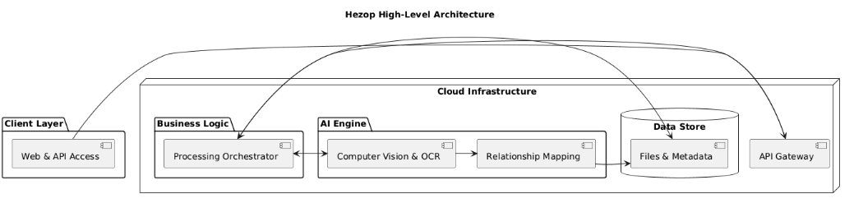

7.3 AI/ML Engine Components
The intelligence core comprises several specialized models:
- Symbol Detector: A convolutional neural network (CNN) trained on thousands of annotated P&ID symbols to locate and classify graphical elements.
- Text Recognizer & Associator: Combines Optical Character Recognition (OCR) for raster images with text extraction from vector PDFs. A spatial reasoning module associates text blocks with their nearest symbol or line.
- Relationship Graph Builder: Applies rule-based and heuristic algorithms on the spatial layout and extracted text (e.g., line numbers) to construct a connectivity graph between entities.
- Continuous Learning Loop: User corrections are anonymized, aggregated, and used to periodically retrain the detection and association models, improving accuracy over time.
8. Process Flows & Use Case Scenarios
8.1 End-to-End Value Chain Process Flow
The following diagram illustrates the complete journey from raw drawing to consumable digital asset.
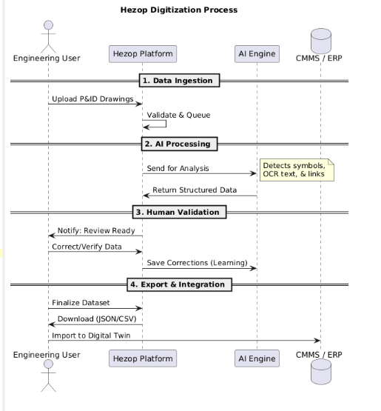
8.2 Core User Workflows
- Project Setup Workflow: User logs in > Creates new project > Uploads batch of drawings > System processes in background.
- Validation Workflow: User selects a project > Opens a sheet > Reviews highlighted symbols > Corrects misidentified tags or connections > Marks sheet as approved.
- Export & Integration Workflow: User selects approved project > Chooses export format (JSON, CSV template) > Downloads file > Uses provided scripts or connectors to load data into target system.
8.3 Detailed Use Case Specifications
Use Case ID: UC-001
Use Case Name: Process a Batch of Legacy Scanned P&IDs
Primary Actor: Digitalization Project Lead
Precondition: User has a folder of scanned PDF P&IDs from a historical plant.
Main Success Scenario:
- User logs into Hezop web portal.
- User creates a new project "Legacy_Plant_Area_A".
- User uploads all PDF files via drag-and-drop.
- System confirms upload and begins processing.
- System sends email notification upon completion (24 hrs later).
- User logs in, navigates to project, and sees an overall accuracy confidence score of 88%.
- User uses the bulk validation tool to filter and review all low-confidence instrument tags.
- User makes corrections over several sessions.
- User finalizes the project and exports a consolidated equipment list (CSV).
- User imports CSV into the corporate asset register.
Postcondition: Legacy plant data is now digitized and available in the corporate system.
Alternate Flows: If bulk upload fails, system provides a detailed error log for problematic files.
9. Data Model & Output Specifications
The core output is a structured JSON document representing the entire project. The schema is based on a graph model where Nodes are entities (Equipment, Instrument, Pipeline) and Edges are relationships (Connects_To, Is_Part_Of).
Field Category | Description | Example
Entity Identification | Unique identifier, entity type, subtype, and plant tag information | id: "EQP-001", type: "Equipment", tag: "T-501"
Geospatial Reference | Bounding box coordinates on the original drawing sheet | "bounding_box": [120, 450, 180, 490]
Relationship | Defines connectivity between entities, including the connecting medium (line) | "from": "P-101A", "to": "V-101", "via": "L-101"
Metadata | Project identifier, drawing sheet, and processing version information | "project_id": "proj_123", "processing_version": "v2.0"

